Other Non-Periodic Tessellations
# Source: AI Source: Provided by: [Data Path: Persons Table -> ID Column: 1, Name_En Column: Motasem Essam] -> From: [ChatGPT] on [7/25/2026]
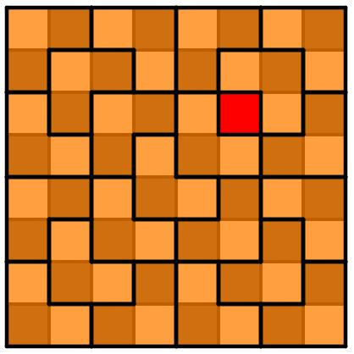
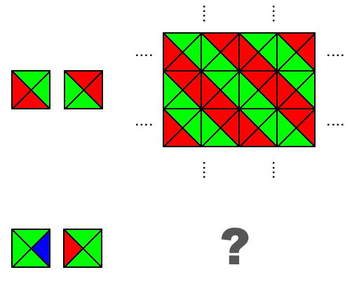

Definition
# Source: AI Source: Provided by: [Data Path: Persons Table -> ID Column: 1, Name_En Column: Motasem Essam] -> From: [ChatGPT] on [7/25/2026]
Other Non-Periodic Tessellations are tessellations that do not have any nonzero translational symmetry, but do not necessarily satisfy the stronger conditions normally associated with an aperiodic tessellation.
In other words, the particular arrangement does not repeat exactly under translation, but it may still contain arbitrarily large periodic regions or patches. (MathWorld)
This category is useful in your taxonomy because:
$$\boxed{\text{Aperiodic Tessellation}⊂\text{Non-Periodic Tessellations}}$$
but not every non-periodic tessellation is aperiodic.

Classification Position
# Source: AI Source: Provided by: [Data Path: Persons Table -> ID Column: 1, Name_En Column: Motasem Essam] -> From: [ChatGPT] on [7/25/2026]
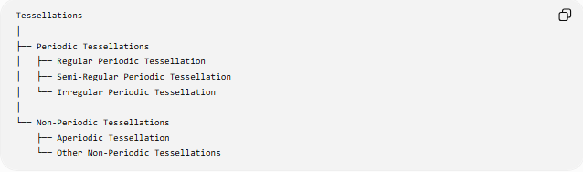
Tessellations
│
├── Periodic Tessellations
│ ├── Regular Periodic Tessellation
│ ├── Semi-Regular Periodic Tessellation
│ └── Irregular Periodic Tessellation
│
└── Non-Periodic Tessellations
├── Aperiodic Tessellation
└── Other Non-Periodic Tessellations
Important mathematical note
The heading "Other Non-Periodic Tessellations" is best treated as a descriptive project category, rather than a universally standardized mathematical class.
Mathematically, non-periodic simply means that no nonzero translation leaves the particular tiling unchanged. (MathWorld)

Fundamental Characteristics

1. No translational symmetry
# Source: AI Source: Provided by: [Data Path: Persons Table -> ID Column: 1, Name_En Column: Motasem Essam] -> From: [ChatGPT] on [7/25/2026]
For a non-periodic tessellation $T$:
$$T+v≠T$$
for every nonzero translation vector $v$.
Therefore, there is no finite fundamental region that can simply be translated repeatedly to reproduce the entire tessellation. (MathWorld)

2. It may still contain large periodic regions
# Source: AI Source: Provided by: [Data Path: Persons Table -> ID Column: 1, Name_En Column: Motasem Essam] -> From: [ChatGPT] on [7/25/2026]
This is what separates an ordinary non-periodic tessellation from an aperiodic one.
Imagine a square tessellation:

□ □ □ □ □ □ □ □ □
□ □ □ □ □ □ □ □ □
□ □ □ □ □ □ □ □ □
□ □ □ X □ □ □ □ □
□ □ □ □ □ □ □ □ □
□ □ □ □ □ □ □ □ □
The single modification $X$destroys the global translational symmetry of the infinite pattern.
However, enormous portions of the plane can still look exactly like the original periodic square pattern.
Therefore, this is non-periodic, but it is not the kind of strongly non-repeating structure represented by an aperiodic tiling. A standard example discussed in the literature is a periodic square tiling modified at one location. (Wikipedia)

3. The irregularity can be localized
# Source: AI Source: Provided by: [Data Path: Persons Table -> ID Column: 1, Name_En Column: Motasem Essam] -> From: [ChatGPT] on [7/25/2026]
One common way to obtain a non-periodic tiling is to start with a periodic tessellation and introduce a localized change.
For example:
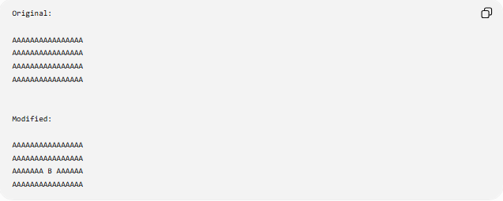
Original:

AAAAAAAAAAAAAAAA
AAAAAAAAAAAAAAAA
AAAAAAAAAAAAAAAA
AAAAAAAAAAAAAAAA

Modified:

AAAAAAAAAAAAAAAA
AAAAAAAAAAAAAAAA
AAAAAAA B AAAAAA
AAAAAAAAAAAAAAAA
The surrounding arrangement can remain periodic over arbitrarily large areas, while the single disturbance prevents the whole infinite tiling from being periodic.

4. It does not have to be geometrically irregular
# Source: AI Source: Provided by: [Data Path: Persons Table -> ID Column: 1, Name_En Column: Motasem Essam] -> From: [ChatGPT] on [7/25/2026]
This is an important point for your Plane Geometry classification.
A non-periodic tessellation can use perfectly regular tiles.
For example:
- squares can be used,
- triangles can be used,
- rectangles can be used,
while a modification or non-repeating arrangement prevents global translational symmetry.
Therefore:
$$\boxed{\text{Non-Periodic}≠\text{Irregular Tiles}}$$
Periodicity and geometric regularity are separate properties.

Other Non-Periodic vs Aperiodic
# Source: AI Source: Provided by: [Data Path: Persons Table -> ID Column: 1, Name_En Column: Motasem Essam] -> From: [ChatGPT] on [7/25/2026]
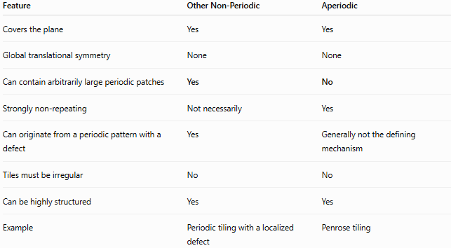
Feature | Other Non-Periodic | Aperiodic
Covers the plane | Yes | Yes
Global translational symmetry | None | None
Can contain arbitrarily large periodic patches | Yes | No
Strongly non-repeating | Not necessarily | Yes
Can originate from a periodic pattern with a defect | Yes | Generally not the defining mechanism
Tiles must be irregular | No | No
Can be highly structured | Yes | Yes
Example | Periodic tiling with a localized defect | Penrose tiling
An aperiodic tiling has the additional condition that arbitrarily large periodic patches do not occur. (MathWorld)

Example: A Square Tiling With One Defect
# Source: AI Source: Provided by: [Data Path: Persons Table -> ID Column: 1, Name_En Column: Motasem Essam] -> From: [ChatGPT] on [7/25/2026]
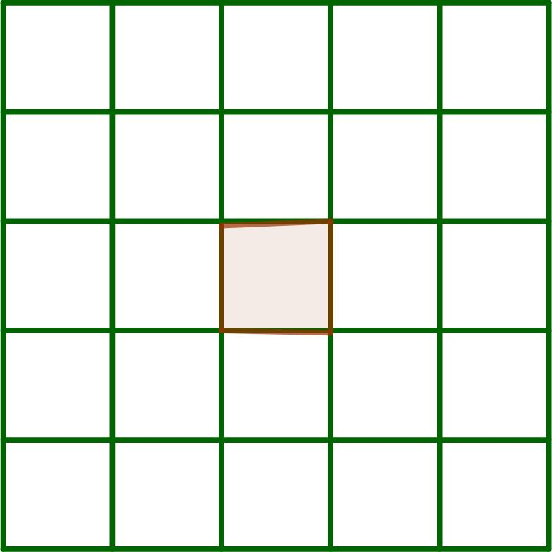
Consider an infinite square grid.
Normally:
$$T+v=T$$
for many translation vectors $v$.
Now modify one square.
The resulting arrangement can satisfy:
$$T+v≠T$$
for every nonzero $v$.
Yet, far away from the defect, the tiling can still contain arbitrarily large areas identical to the original square grid.
Thus:
$$\boxed{\text{Non-Periodic but not Aperiodic}}$$
This exact distinction is used in mathematical discussions of non-periodic versus aperiodic tilings. (Wikipedia)

Example: Non-Repetitive Non-Periodic Arrangement
# Source: AI Source: Provided by: [Data Path: Persons Table -> ID Column: 1, Name_En Column: Motasem Essam] -> From: [ChatGPT] on [7/25/2026]
Another possibility is a tiling in which certain local configurations occur only a finite number of times or are distributed irregularly.
The Tilings Encyclopedia distinguishes repetitive and non-repetitive non-periodic tilings; random tilings are one example of non-periodic structures that need not have the repetitive behavior found in many well-studied aperiodic systems. (Tilings Encyclopedia)
So your category can include more than simply "periodic tiling + one defect."

Relationship With Aperiodic Tessellation
# Source: AI Source: Provided by: [Data Path: Persons Table -> ID Column: 1, Name_En Column: Motasem Essam] -> From: [ChatGPT] on [7/25/2026]
The relationship can be represented as:
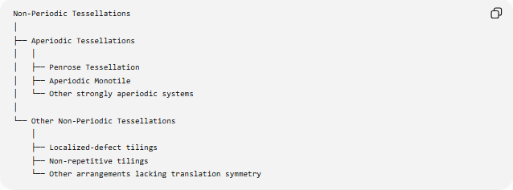
Non-Periodic Tessellations
│
├── Aperiodic Tessellations
│ │
│ ├── Penrose Tessellation
│ ├── Aperiodic Monotile
│ └── Other strongly aperiodic systems
│
└── Other Non-Periodic Tessellations
│
├── Localized-defect tilings
├── Non-repetitive tilings
└── Other arrangements lacking translation symmetry
The key distinction is:
$$\boxed{\begin{matrix}\text{Non-Periodic} \\ \text{No global translation symmetry}\end{matrix}}$$
versus
$$\boxed{\begin{matrix}\text{Aperiodic} \\ \text{No global translation symmetry} \\ +\text{No arbitrarily large periodic patches}\end{matrix}}$$
(MathWorld)

Comparison With Periodic Tessellations
# Source: AI Source: Provided by: [Data Path: Persons Table -> ID Column: 1, Name_En Column: Motasem Essam] -> From: [ChatGPT] on [7/25/2026]
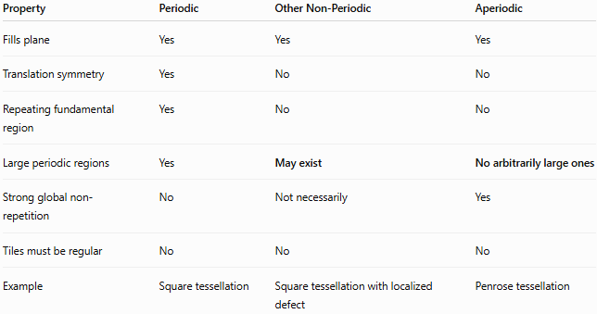
Property | Periodic | Other Non-Periodic | Aperiodic
Fills plane | Yes | Yes | Yes
Translation symmetry | Yes | No | No
Repeating fundamental region | Yes | No | No
Large periodic regions | Yes | May exist | No arbitrarily large ones
Strong global non-repetition | No | Not necessarily | Yes
Tiles must be regular | No | No | No
Example | Square tessellation | Square tessellation with localized defect | Penrose tessellation

Important Taxonomy Correction
# Source: AI Source: Provided by: [Data Path: Persons Table -> ID Column: 1, Name_En Column: Motasem Essam] -> From: [ChatGPT] on [7/25/2026]
For your knowledge base, I recommend keeping this distinction:
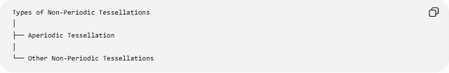
Types of Non-Periodic Tessellations
│
├── Aperiodic Tessellation
│
└── Other Non-Periodic Tessellations
But add the following note:
"Other Non-Periodic Tessellations" is a project-level descriptive category, not a standard exhaustive mathematical classification.
This prevents the taxonomy from implying that mathematicians universally divide all non-periodic tessellations into exactly these two named types.

Key Properties
# Source: AI Source: Provided by: [Data Path: Persons Table -> ID Column: 1, Name_En Column: Motasem Essam] -> From: [ChatGPT] on [7/25/2026]
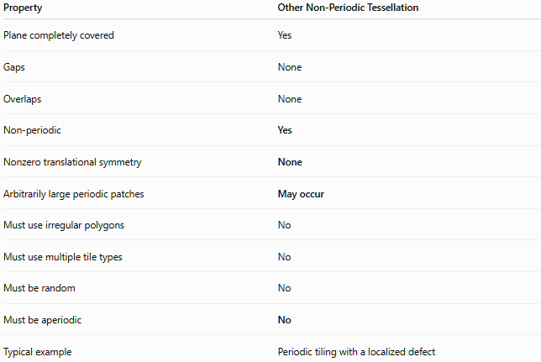
Property | Other Non-Periodic Tessellation
Plane completely covered | Yes
Gaps | None
Overlaps | None
Non-periodic | Yes
Nonzero translational symmetry | None
Arbitrarily large periodic patches | May occur
Must use irregular polygons | No
Must use multiple tile types | No
Must be random | No
Must be aperiodic | No
Typical example | Periodic tiling with a localized defect

Conclusion
# Source: AI Source: Provided by: [Data Path: Persons Table -> ID Column: 1, Name_En Column: Motasem Essam] -> From: [ChatGPT] on [7/25/2026]
An Other Non-Periodic Tessellation is a tessellation that lacks global translational symmetry but does not necessarily have the stronger aperiodic property.
The simplest conceptual example is a periodic tessellation with a localized defect: the defect destroys the global periodicity, while arbitrarily large regions can remain identical to the original periodic pattern. (MathWorld)
The fundamental relationship is:
$$\boxed{\text{Aperiodic Tessellation}⊂\text{Non-Periodic Tessellations}}$$
Therefore, your classification should distinguish ordinary/non-strongly non-periodic arrangements from genuinely aperiodic tessellations.

